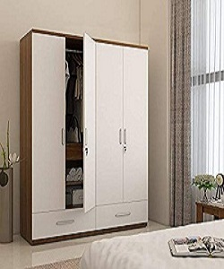

Wardrobe

$176.47

Availability: In stock

Description

The ultra-modern Wardrobe will transform an ordinary bedroom into the Centre of attention. With its curvaceous contour surface, this will gives a fashionable look to your room. The nature and design of this allows it to suit most modern bedrooms.